Network Topology Architecture   
2-Tier & 3-Tier Architectures

# **Three Tier:**

* The Three Tier (3 Tier) Architecture is a great solution for large enterprises.
* Cisco suggests 3 Tier hierarchical network model, that consists of three layers.
* The Three Tier are the Core layer, the Distribution layer, and the Access layer.
* Cisco Three-Layer network model is the preferred approach to network design.
* Maximizes performance, network availability & ability to scale network design.

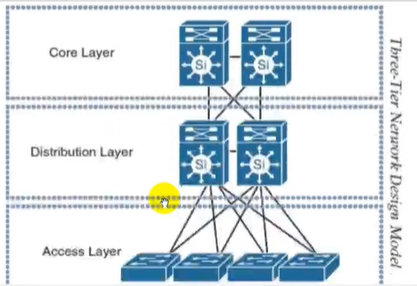

**Core Layer:**

* Core Layer consists of biggest, fastest & most expensive routers with highest model.
* In the Three Tier Architecture, the Core Layer is the one coordinating everything.
* Its only role is to forward traffic, the fastest it can, here you don't apply any policy.
* Where several distribution switches, Core Layer is considered as backbone of networks.
* Core Layer routers or switches are used to merge geographically separated networks.
* The Core Layer routers or switches move information on the network as fast as possible.
* Core switches talk with distribution switches using dynamic routing protocols, like OSPF.
* At this layer, most advanced & expensive switches used ones with modular form factor.
* The Core Layer can provide the high-speed switching, reliability and fault tolerance.

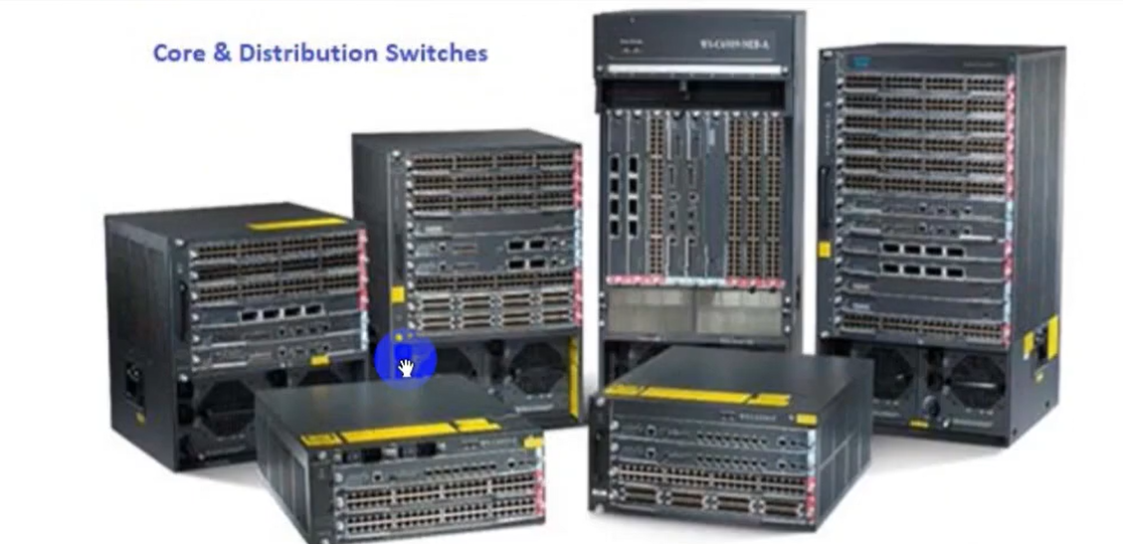

**Distribution Layer:**

* The Distribution Layer is located between the Access Layer and the Core Layers.
* This layer is to provide boundary definition by implementing access lists & other filters.
* The Distribution Layer defines policy for network and include high-end Layer 3 switches.
* Distribution Layer ensures that packets are properly routed between subnets and VLANs.
* The Distribution Layer can provide, Aggregation of Local Area Network or WAN links.
* This Layer provide Policy-based security in form of access control lists (ACLs) and filtering.
* Also Provide, Routing services between LANs and VLANs and between routing domains.
* Distribution Layer provide Redundancy, load balancing, aggregation & summarization.
* Broadcast domain control, routers or multilayer switches do not forward broadcasts.

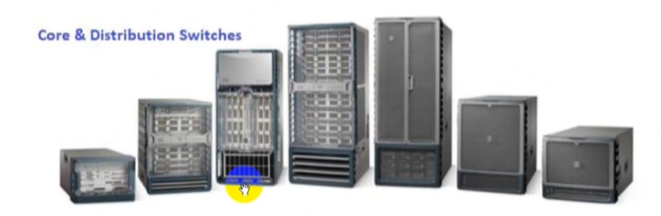

**Access Layer:**

* The Access Layer is the one closer to the users, at this layer we find the users themselves.
* The Access layer includes access switches which are connected to the end devices.
* Access layer switches ensures that packets are delivered to the end points or devices.
* The main purpose of the Access Layer is to physically connect users to the network.
* There is just a cable between end-user or end points PCs and access-layer switches.
* These are security policies we want to enforce in order to allow access to the network.
* For example, we can configure port-security and Network Access Control in this layer.
* The Access Layer can provide, Layer 2 switching, High availability, and Port security etc.
* Also provide, QoS classification, address Resolution Protocol (ARP) inspection & VLANs.
* Virtual access control lists (VACLs), Spanning tree, Power over Ethernet (POE) and VoIP.

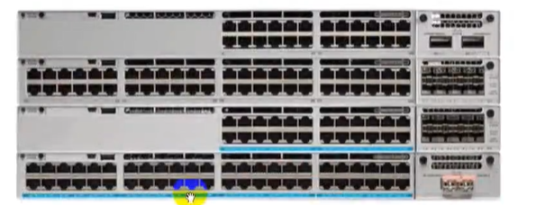

# **Two Tier:**

* Two Tier design model is more suitable for small to medium-size campus networks,
* Core & distribution functions can be combined into one, also known as collapsed core.
* Collapsed Core is when distribution & core layer functions are implement by single device.
* The primary motivation for the collapsed core design is to reduce the network cost.
* In two Tier still maintaining most of the benefits of the three-tier hierarchical model.

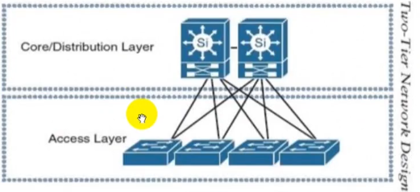

## **Benefits of Hierarchical Model:**

* Main benefits help to design, deploy & maintain scalable hierarchical internetwork.
* Three-Layer or 2-layer network model allows in creating high performance networks.
* It allows better network management and isolate causes of network trouble & issue.
* Cisco Three Layer Network Model allows better filter & policy creation application.
* Cisco Three Layer Network Model allows us to efficiently accommodate future growth.
* Three Layer or Two Layer Network Model provides better redundancy & availability.
* Multiple links across multiple devices provides better redundancy and availabilities.
* If one switch is down, we have another alternate path to reach the destination.
* When the network grows, we can easily add more distribution or access layer switches.